Hillcrest School and Sixth Form

KNOWLEDGE ORGANISER

YEAR 8 TERM 3B – AREA, VOLUME AND SURFACE AREA

**KEY WORDS and INFORMATION**

**OUTCOMES**

|  |
| --- |
| • Explore the relationship between circumference and  diameter |
| • Calculate area and circumference |
| • Area and perimeter of composite shapes |
| • Use the formulae to calculate the volume of cubes,  prisms and composite solids |
| • Changing between units of volume |
| • Recognising and drawing nets of prisms |
| • Using the formulae to calculate the surface area of  cubes, prisms and composite solids |

Perimeter- The distance around a 2D shape.

Area- The amount of square units that fit inside the shape.

Composite shape-  is a **shape** that is made up of two or more **shapes**.

Radius- Distance from the centre of a circle to the edge.

Diameter- Distance from the one point on a circle through the centre to another point on the circle.

Circumference – distance around the outside of a circle.

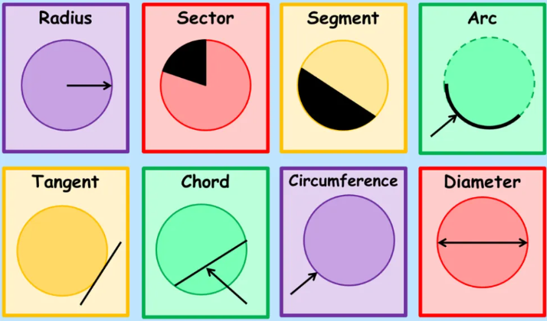

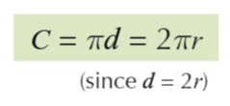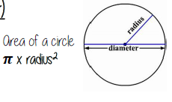

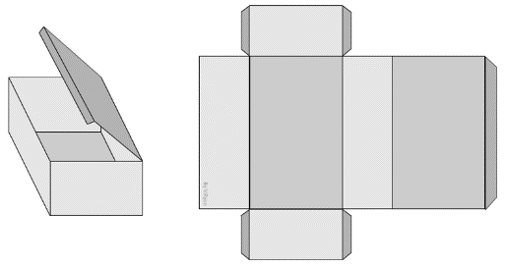

Net- A 3D shape cut open and flattened, when folded it should make the 3D shape.

Prism- A solid object with two identical ends and flat sides.

Surface area- The area of each face adds together to give the total surface area.

Volume – The amount of 3D space something takes up.

**RESOURCES**



**Clip Numbers**

***332-341, 81, 84-90, 96***

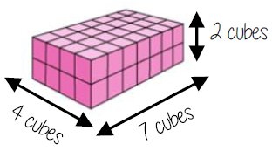

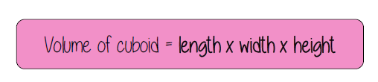

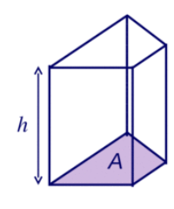

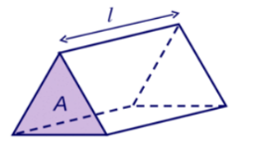

Volume of

a prism

Cross section

area

=

X length