Conflict and Tension: Peacemaking
1 | WWI ended in1918, with the Allies defeating the Central Powers. World leaders met in Versailles to agree a peace settlement. The agreement was very harsh to Germany. Other treaties were harsh to other Central Powers.
Key events
2 | 1918 | End of WWI
3 | 1919 Jan | Jan: Paris Peace Conference
4 | 1919 June | Treaty of Versailles signed
5 | 1919: Nov | Treaty of Neuilly
6 | 1920: June | Treaty of Trianon
7 | 1920: Aug | Treaty of Sevres
8 | 1921 | Reparations for the Treaty of Versailles set at £6.6billion
9 | 1923 | Treaty of Lausanne
10 | 1923 | Occupation of the Ruhr
Key ideas and developments
11 |  | Big Three | The leaders of Britain (Lloyd George), France (Georges Clemenceau) and the USA (Woodrow Wilson). They were the most powerful world leaders and they decided the Treaties. They had different ideas about how Germany should be treated.
12 |  | Wilson & the USA  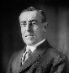 | Compared to other countries, there was little damage from WWI and few soldiers had died. Wilson had 14 key ideas about setting up a fair and peaceful system called the 14 points (e.g. self-determination). Wilson and the US population thought the treaties were too harsh. America became isolationist.
13 |  | Clemenceau & France  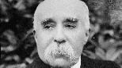 | A lot of the fighting had happened in France, and many French soldiers had died. There was huge economic damage to France (estimated 200 billion Francs). Clemenceau and France wanted revenge and to be protected from possible future attacks by Germany. They thought the treaties were not harsh enough.
14 |  | Lloyd George & Britain  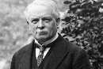 | The damage to the UK was somewhere between the USA and France. Many in Britain wanted revenge, but Lloyd George recognised that a harsh treaty would make Germany bitter and may lead to another war. He also wanted to keep Germany’s economy strong enough to trade with Britain. Reaction to the treaties in Britain and by Lloyd George was mixed.
15 |  | Treaty of Versailles | Reparations £6.6 billion; loss of land to Poland and France; military restrictions (army: 100,000); forced to accept war guilt.
16 |  | Diktat | The Treaty of Versailles was hated in Germany. There were protests all around the country. It was called a ‘diktat’ (dictated peace, as they were forced to accept it). The SPD who signed it were called ‘November Criminals’ by many people.
17 |  | Treaty of St Germain | Austria lost land to Italy and Romania. There were military restrictions (30,000 in the army). Austria forbidden from uniting with Germany. Had to pay reparations – but the amount was never fixed.
18 |  | Treaty of Neuilly | Bulgaria lost land to Yugoslavia, Greece and Romania and had to pay £100 million reparations. Military restrictions (army: 20,000).
19 |  | Treaty of Trianon | Hungary lost land to Romania, Czechoslovakia, Yugoslavia and Austria. Reparations were agreed, but the amount was not fixed. Military restrictions (30.000 in the army).
20 | Treaty of Sevres |  | Turkey lost land to Greece, the Ottoman (Turkish) Empire was split up and the army was restricted to 50,000 men. Huge losses of land. Turkish people were so angry they revolted and overthrew the government, leading to…
21 | Treaty of Lausanne |  | A new treaty for Turkey. Some land was returned from Greece and they had more control over the seas around Turkey. Reparations cancelled and no army restrictions any more.
22 | New states (countries) |  | Lots of new countries were established after WWI: Poland, Czechoslovakia, Romania and Yugoslavia. Some of these countries did well, but many struggled.

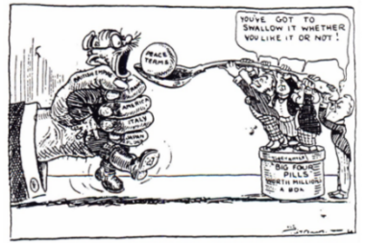 | Cartoon from a British magazine against the Treaty of Versailles. Germany is shown being forced by the Big Tree to ‘swallow’ peace terms that are far too big
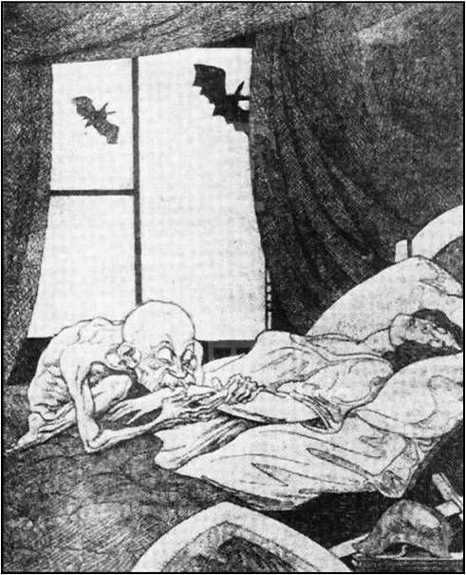 | German political cartoon showing Clemenceau as a vampire, sucking the vitality out of Germany, whose weapons are laid aside whilst bats representing Wilson and Lloyd George fly outside the window

Word | Definition and characteristics | Related words | Examples in a sentence
isolationism  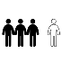 | When a country keeps itself separate and does not want to work together with other countries. | - isolate – to separate | - America moved towards a policy of isolationism in the 1920s.
occupation  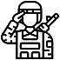 | When one country controls another country (or an area of another country) using its army.  (A different definition of ‘occupation’ is a person’s job.) | - occupy – to take control of something | - The Occupation of the Ruhr started when Germany got behind with reparations payments.  - France and Belgium occupied the Ruhr.
reparations  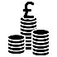 | Money that has to be paid to ‘pay back’ for something – as a punishment. | - repay – to give back  - repair – make better | - Germany had to pay reparations to the Allies.
revolution  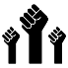 | A violent fight against someone in power with the aim of getting rid of them and replacing them with new leaders; a huge change to a system or way of doing things | - revolt – a protest against the people in power | - The 1917 Revolution in Russia established Communism in the country.
self-determination  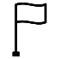 | When a country can decide if it wants to be independent, rather than part of or controlled by another country | - determine – decide | - Woodrow Wilson argued that countries should have self-determination after WWI.  - Poland’s independence after WWI is an example of self-determination.
treaty | A formal, legal agreement between two countries. Treaties are usually named after the place they are agreed. | - treat – to negotiate | - The Treaty of Versailles punished Germany for starting WWI.  - Germany and Italy signed a treaty.

Conflict and Tension: The League
1 | The League of Nations was set up by the Treaty of Versailles. It was an international organisation with the aim of maintaining peace throughout the world. It had some successes, but also struggled to achieve its aims.
Key events
2 | 1919 June | Treaty of Versailles signed
3 | 1920 Jan | First meeting of the League of Nations
4 | 1921 | Vilna Crisis; Åaland Island Crisis; Upper Silesia
5 | 1922 Aug | Washington Naval Agreement; Mussolini takes control
6 | 1922: Oct | Mussolini becomes dictator in Italy
7 | 1922-3 | Economic collapse in Austria and Hungary
8 | 1923 | Corfu Crisis
9 | 1925 | Greece-Bulgaria Dispute; Locarno Treaties
10 | 1926 | Germany joins the League
11 | 1928 | Kellogg-Briand Pact
12 | 1929 | Wall Street Crash leads to global depression
13 | 1931 | Mukden Incident and start of Manchurian Crisis
14 | 1933 | Hitler becomes Chancellor
15 | 1934 | USSR joins League of Nations
16 | 1935 | Abyssinian Crisis
17 | 1939 | Outbreak of WWII
Key ideas and developments
18 | League of Nations | The League was an international organisation which aimed to bring countries together to find peaceful solutions to conflicts. It struggled with membership: some countries (e.g. Germany) were not allowed to join and others (e.g. America) did not join. They had no army and decision-making was slow.
19 | Kellogg-Briand Pact | Sixty-five countries agreed to solve disputes peacefully rather than using war. This was a positive step, but the fact it had nothing to do with the League demonstrates that the League struggled to actually get things done.
20 | The League in the 1920s | They had some successes (e.g. a peaceful agreement between Sweden and Finland over who should control the Åaland Islands), but they did nothing when Poland took the Lithuanian city of Vilna by force and their response to a crisis in Bulgaria was seen as weak.
21 | Great Depression | An economic crisis that started when the American stock market crashed and spread throughout the world. It caused very high unemployment across the world (though America and Germany were worst hit). During the depression, most countries focused on solving their own economic problems rather than international cooperation.
22 | Manchurian Crisis | Japan invaded part of China. Japan was a powerful member of the League of Nations and claimed that China had attacked first. The League issued a moral condemnation but didn’t have a strong response: there were no trade sanctions and Japan stayed in Manchuria.
23 | Abyssinian Crisis | Italy invaded Abyssinia, a country in Africa. The League’s response was weak: they banned trading weapons with Italy but allowed trade in oil and coal to continue. They also allowed Italy to keep control of some of Abyssinia.
24 | Outbreak of WWII | This was the ultimate failure for the League of Nations, an organisation that was set up to prevent war.

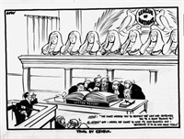 | Trial by Geneva’ – the judges represent the League of Nations. The Japanese man in the bottom left is making fun of the League.
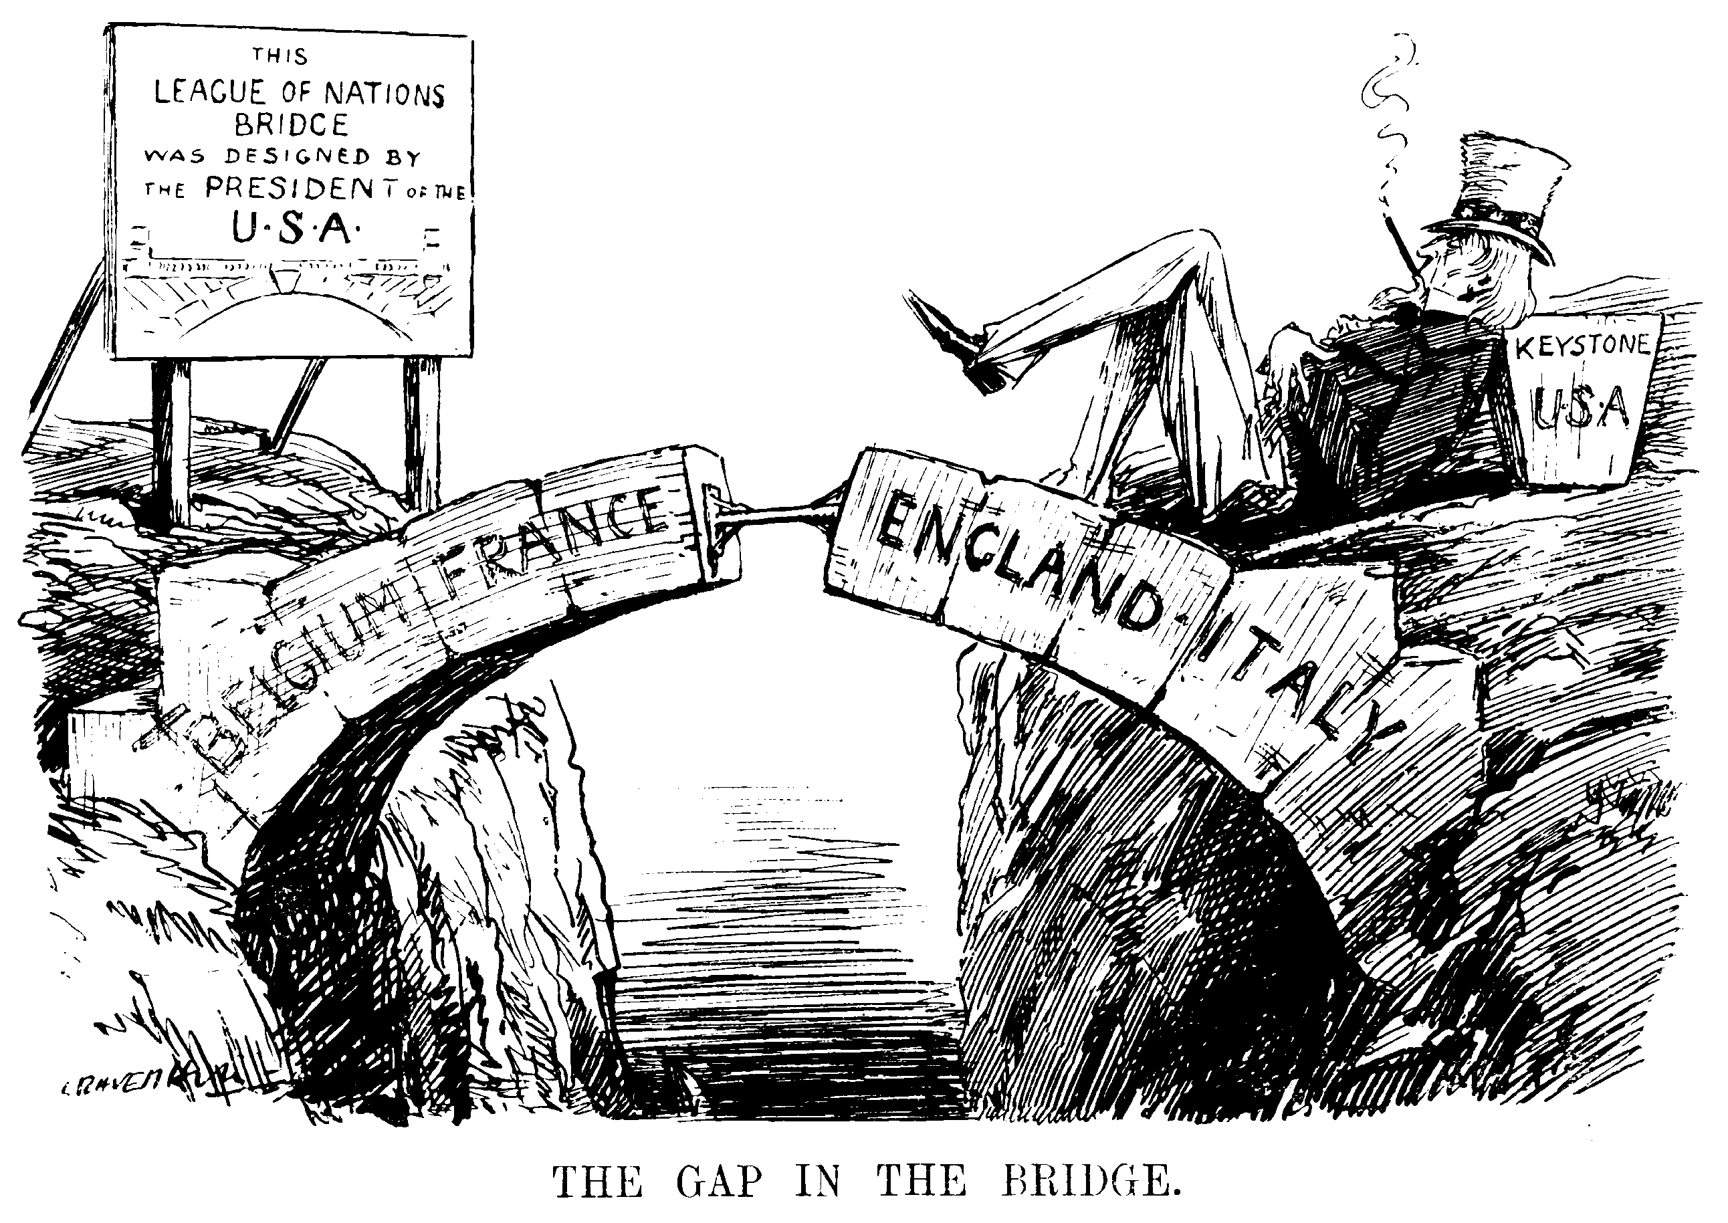 | Gap in the Bridge’ – this political cartoon shows the idea that, without America (represented by ‘Uncle Sam’), the League of Nations was weak.

Word | Definition and characteristics | Related words | Examples in a sentence
cooperation | To work together. | - Cohabitation – to live together  - Operate – to control how something works | - There was increased international cooperation in the 1920s.
depression | In economics, a long term drop in an economy, where trade and production are reduced and unemployment increases. | - Depress – to press down. | - The Great Depression caused a decline in international cooperation.
moral condemnation | An official action that could be taken by the League of Nations to express official disapproval of the actions of a country. | - Morals – beliefs  - Damn – strongly criticise or doom to failure | - The League issued a moral condemnation to Japan over its actions in Manchuria.  - Italy ignored the moral condemnation issued by the League after it invaded Abyssinia.
naval | Relating to the navy. | - Navy – the part of the military that works at sea | - The Washington Naval Agreement led to a reduction in the size and power of many navies across the world.
pact | A formal (official) agreement between individuals or countries. |  | - The Pact of Steel was an agreement between Germany, Japan and Italy.
trade sanctions | An official action that could be taken by the League of Nations, where a country which had done something wrong would be prevented from trading as a punishment. | - Tread – to step, related to the word ‘trade’ | - The League imposed trade sanctions on Italy after the invasion of Abyssinia.  - The League decided not to impose trade sanctions on Japan
veto | Noun: the power to vote against something to prevent it from happening  Verb: the act of voting against something to prevent it from happening. |  | - Germany vetoed the League’s attempt to protect Jewish refugees fleeing from the Nazis.

Conflict and Tension: Road to WWII
1 | The Second World War started in 1939. It was caused by many factors: the weakness of the League of Nations, the Great Depression, the Nazi-Soviet Pact, and the policy of appeasement by Britain and France.
Key events
2 | 1933 | Hitler becomes Chancellor of Germany
3 | 1934 | The Dollfuss Affair
4 | 1935 Jan | In the Saar Plebiscite, the Saar votes to re-join Germany
5 | 1935 Mar | Hitler announces the build-up of the German military
6 | 1935 June | Anglo-German Naval Treaty
7 | 1936 Jul | Outbreak of the Spanish Civil War
8 | 1936 Oct | Rome-Berlin Axis
9 | 1936 Nov | Anti-Comintern Pact
10 | 1938 Mar | Remilitarisation of the Rhineland; Anschluss
11 | 1938 Sept | Sudeten Crisis and Munich Agreement
12 | 1938 Oct | Invasion of Sudetenland by the Nazis
13 | 1939 May | Pact of Steel: military alliance between Germany and Italy
14 | 1939 Aug | Nazi-Soviet Pact
15 | 1939 Sep | Hitler invades Poland; Britain and France declare war on Germany
Key ideas and developments
16 | Nazism | An ideology which included extreme nationalism and militarism along with absolute hatred of the Treaty of Versailles. Hitler wanted to unite all German-Speaking peoples as well as take ‘living space’ from countries he saw as inferior.
17 | Dollfuss Affair | The Nazis had a branch of their party in Austria. The Austrian Nazis murdered Dollfuss, the Chancellor.
18 | Appeasement | The policy pursued by British Prime Minister Chamberlain that some of Hitler’s demands in order to keep him under control.
19 | Anti-Comintern Pact | An agreement by Germany, Japan and Italy against Communism (specifically against the USSR). The Comintern was ‘Communist International’ – part of the USSR’s government dedicated to spreading Communism throughout the world. The USSR, or Union of Soviet Socialist Republics, was a communist country run from Russia between 1917 and 1991.
20 | Anschluss | Literally translates as ‘union’ – the joining together of Austria and Germany. This was achieved when Hitler marched into Austria with his army. It went against the Treaty of Versailles.
21 | Munich Agreement | An agreement made as part of appeasement. Britain agreed to Hitler taking control of Sudetenland because he said it would be his last move in Europe.
22 | Sudeten Crisis | Hitler took control of Sudetenland, part of Czechoslovakia, with the support of Britain, France and Italy because of the Munich Agreement. Soon after, Hitler invaded the rest of Czechoslovakia. It was clear that appeasement had failed.
23 | Nazi-Soviet Pact | An agreement between Nazi Germany and the Communist USSR. Germany and the USSR both agreed that the other could control half of Poland (Poland did not agree).
24 | Start of WWII | Hitler invaded Poland in 1939, with the support of the USSR because of the Nazi-Soviet Pact. Britain gave Germany an ultimatum, i.e. a demand that if they did not end the invasion, Britain would declare war. Germany did not end the invasion, and Britain declared war on Germany.

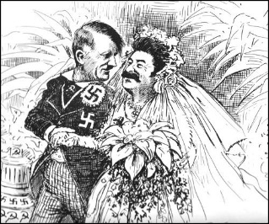 | Political cartoon about the Nazi-Soviet Pact, showing an awkward ‘marriage’ between Hitler and Stalin.
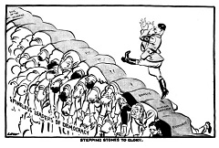 | Political cartoon by British cartoonist Norman Low, showing Hitler making fun of the ‘spineless leaders of democracy’ as he marches over their backs to become ‘boss of the universe’

Word | Definition and characteristics | Related words | Examples in a sentence
affair | An event or sequence of events, particularly if it is very important, concerning or controversial. |  | - The Dollfuss Affair did not result in the Nazis taking control of Austria.
appeasement | To pacify (calm down) someone by accepting their demands; in this context, the attempts to control Hitler by negotiating with him. | - Peace – tranquillity; absence of war | - Neville Chamberlain tried to contain Hitler with a policy of appeasement.
civil war | A war which is between different groups of citizens from the same country. | - Civilian – an ordinary citizen who is not part of the army. | - The Spanish Civil War was won by Franco’s fascists.
plebiscite | When everyone from a country/area votes on an important question. | - Pleb – an ordinary person, sometimes used as an offensive way of saying someone who is ‘low class’ | - A plebiscite was part of the League’s response to the disagreement over Upper Silesia.  - The Saar Plebiscite resulted in the area being returned to Germany.
fascist | A member or believer in a political party which emphasises militarism and extreme nationalism, and one strong leader who will be the country’s ‘saviour’. The first fascists were Mussolini’s Italian Fascists. | - Fascism – the political belief system based on the fascists | - Mussolini was the fascist dictator of Italy.  - Franco led the Spanish fascists.  - Nazism is often seen as a form of fascism.
socialist | A supporter of socialism, a set of political ideas which argues for sharing out of resources (e.g. money). Socialists can be democratic or revolutionary (revolutionary socialists are the same as communists). | - Society – people living together in a community, e.g. a national community  - Social – with other people | - The socialists lost the Spanish civil war.  - Hitler hated socialism.
communist | A political system which argues for getting rid of private ownership so that no-one has any property but everyone has what they need. In practice, communism results in business being owned by the government through dictatorship. | - Communal – owned or used by everyone  - Community – a group of people together in a place – anything from a school to the world! | - The USSR was the first communist nation.

