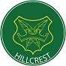
Hillcrest School and Sixth Form
Department of Mathematics KNOWLEDGE ORGANISER
YEAR 10 Foundation Chapter 14: Geometry and measures: Volume & Surface area of Prisms
KEY WORDS and INFORMATION
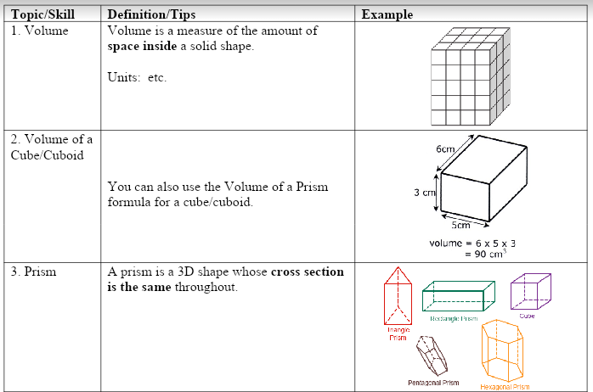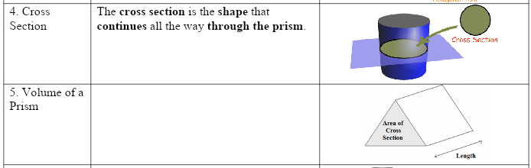

OUTCOMES
• use the correct terms when working with 3D shapes.

• calculate the surface area and volume of a cuboid.

• calculate the volume and surface area of a prism.

• calculate the volume and surface area of a cylinder.

RESOURCES

Clip Numbers
567 - 591

