Assessment, Data and Feedback Policy

Date Policy due to be reviewed: September 2024

Committee Responsible for Policy: Curriculum Committee

Aims

The policy aims to:

- Provide clear guidelines on our approach to formative and summative assessment
- Establish a consistent and coherent approach to recording summative assessment outcomes

Principles of Assessment

Assessment is the range of activities through which we come to know about the abilities and achievements of our students and the extent of the knowledge, skills and understanding that they have developed. It is the vehicle by which we can advise students (and others) of their progress, their targets and how close the gap might exist between their targets and level of attainment. It is an integral part of effective teaching and learning.

This policy will enable us to:

- build a clear picture of each pupil’s skills, knowledge, understanding and approaches to learning;
- identify each pupil’s strengths and the priority areas for their future learning;
- identify an appropriate curriculum for each pupil;
- identify the progress made over a series of lessons;
- evaluate the progress that each pupil is making over time;
- evaluate and improve the teaching strategies used with each pupil;
- keep the leadership team informed, allowing them to make judgments about the effectiveness of the school.
- provide regular information for parents/carers to enable them to work in partnership with the
school to support their pupil’s learning.
- support pupils, where appropriate, to monitor their own learning;
- identify, celebrate, and share achievements.

Assessment approaches

At Hillcrest School, we see assessment as an integral part of the teaching and learning process. To achieve full curriculum coherence, the curriculum intent and its successful delivery need to be assessed to determine the impact of our curriculum.

In school, formative assessment

This refers to a wide variety of assessment methods that teachers use to conduct informal evaluations of student comprehension, learning needs, and academic progress during a lesson, unit, or course.

Effective in-school formative assessment enables:

    - Teachers to identify how pupils are performing on a continuing basis and use this information to provide appropriate support or extension, evaluate teaching and plan future lessons.
    - Pupils to measure their knowledge and understanding against success criteria and identify areas in which they need to improve.
    - Parents/Carers to gain a broad picture of where their child’s strengths and weaknesses lie and what they need to improve.

Teachers demonstrating good practice will:

    - Circulate throughout every lesson, periodically checking pupils’ work to assess learning and check for understanding.
    - Use effective questioning to help assess understanding and identify any misconceptions.
    - Model effectively so that students know what mastery looks like.
    - Encourage students to review and reflect on work that does not meet the necessary expectations.

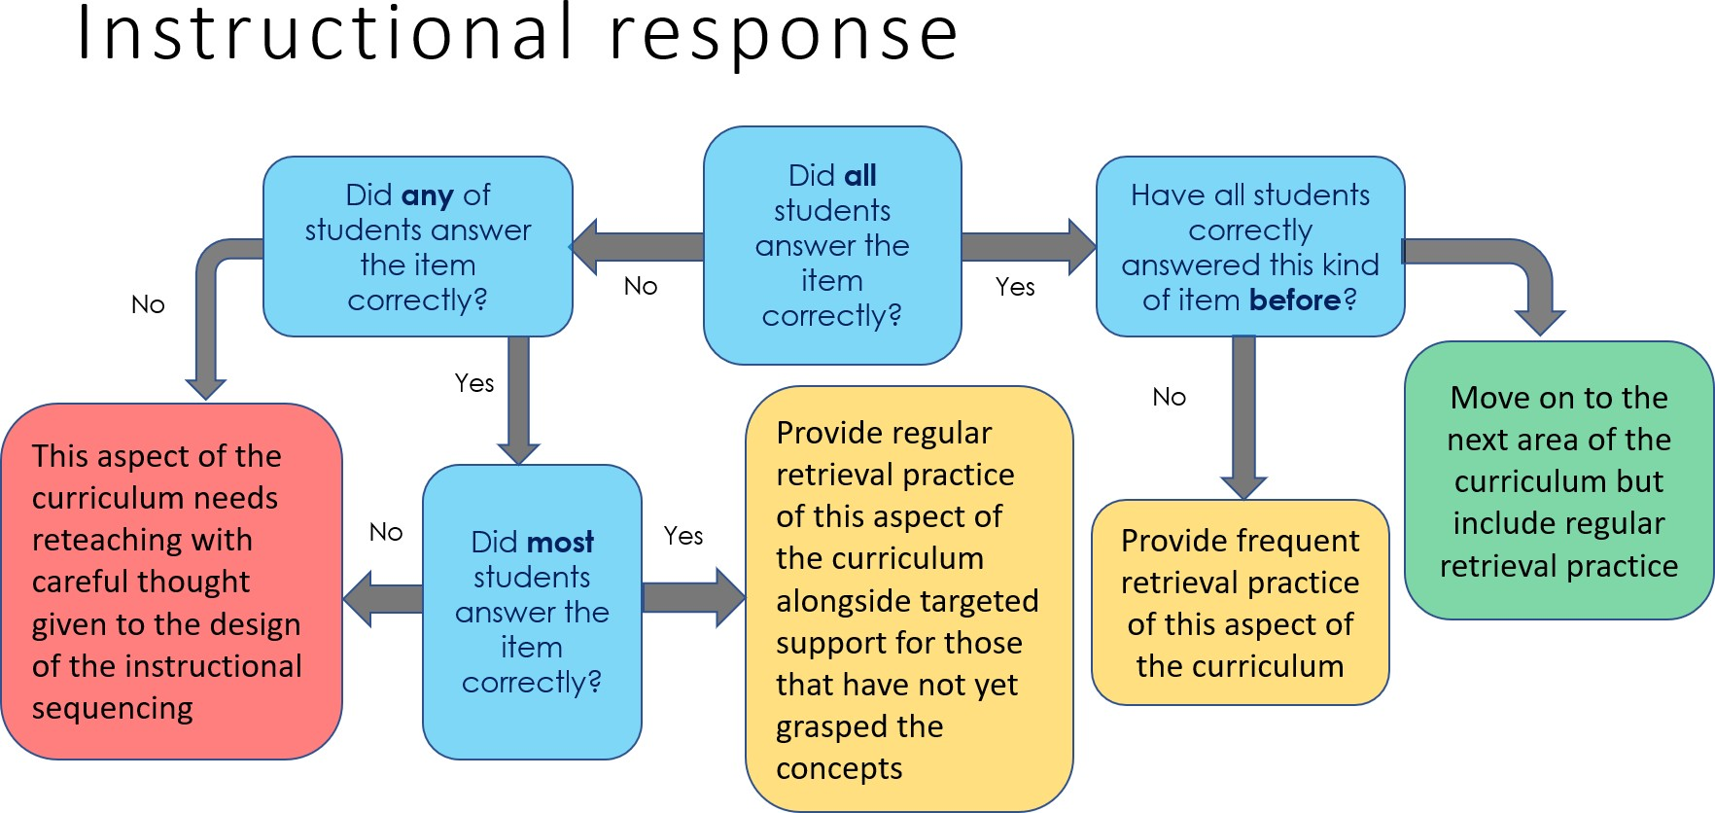

In school summative assessments

Summative assessments are used to evaluate student learning, skill acquisition, and academic achievement at the conclusion of a defined instructional period- typically at the end of a unit, term, or school year.

Effective in-school summative assessment enables:

    - School leaders to monitor the performance of pupil cohorts, identify where interventions may be required, and work with teachers to ensure pupils are supported to achieve sufficient progress and attainment.
    - Teachers to evaluate learning at the end of a unit or period and the impact of their own teaching.
    - Pupils to understand how well they have learned and understood a topic or course of work taught over a period. It should be used to provide feedback on how they can improve.
    - Parents/Carers to stay informed about the achievement, progress, and wider outcomes of their child across a period.
Summative assessments will take place throughout the year, depending on the year group and subject. All key assessment results will be recorded, which allows parents/carers, students, and teachers’ necessary access. The aim of summative assessments is to help identify what a student knows and doesn’t know; the number or grade attached to the assessment is of less importance. Students are expected to reflect on summative assessments and will be allocated time to review and improve their answers. Teachers will conduct question-level analysis and set aside time to re-teach and review key topic areas.

Summative assessments are designed to assess the entire curriculum taught to that point; questions are specifically designed to cover key areas from previous topics in line with how GCSE examinations work; this allows us to see how well pupils have committed knowledge to their long-term memory.

Key Assessment Tasks

    - All students in every year group should undertake at least three key assessment tasks during the academic year, which are marked in detail. The marking must signal clearly that work has been checked for accuracy of content and literacy; must use the WWW and NTT (Now Try This) system.

Nationally standardised summative assessment

Nationally standardised summative assessment enables:

    - School leaders to monitor the performance of pupil cohorts, identify where interventions may be required, and work with teachers to ensure pupils are supported to achieve sufficient progress and attainment.
    - Teachers to understand national expectations and assess their own performance in the broader national context.
    - Pupils and Parents/Carers to understand how pupils are performing in comparison to pupils nationally.
Nationally standardised summative assessments take the form of GCSEs and vocational qualifications at the end of Key Stage 4. KS3 students will complete GL progress testing in Maths for baseline testing.
These are standardised tests which allow us to gauge the progress of our students against the progress made by students nationally. GL testing will take place at the end of each academic year.

All students complete a GL assessment test at the beginning and end of each academic year to gauge reading progress.

Data Entries

Attainment data is inputted into the whole-school system three times per year for each student. Learning Managers are responsible for the data reported for their subject in the school system since this data identifies areas of success as well as the need for intervention. This data will be shared with Ofsted, parents/carers, and students; it must be moderated and accurate to ensure that it is meaningful.

Learning Managers will monitor attainment data, ensuring that:

- Appropriate data based on a range of skills, knowledge and understanding is entered by the team for each reporting or data session.
- Targets reflect national aspirational levels of achievement.
- Interventions are in place so that students make at least ‘Good’ progress between KS2 and KS4.

Departmental recording systems will:

- Be manageable, accurate and understood by a variety of users.
- Record students’ attainment, linking this to the GCSE, BTEC or A Level grading system.
- Enable progress to be tracked, guiding future work and interventions.

This data will:

- Underpin explicitly the strategies used to adapt teaching to respond to the strengths and needs of all students (Standard 5 of the teachers’ standards).

Name of responsible person: S Abbotts - DHT Date reviewed by SLT: September 2022 Date reviewed by governors: September 2022 Date of next review: September 2023

