3b Python Programming

String Methods | Operators
String methods format or change the way a string looks.  lower () Turns all characters into lowercase  upper () Turns all characters into uppercase  title () Turns the first character in each word uppercase  swapcase () Changes to the opposite case  capitalize () Capitalises each word  len () Prints the length of a string | There are two types of operators in Python:  Arithmetic operators – allow us to create mathematical programs  Comparison operators – allows us to compare data in a program.  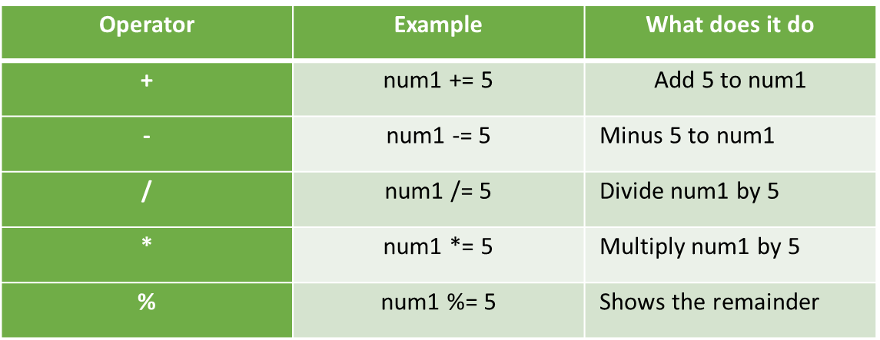  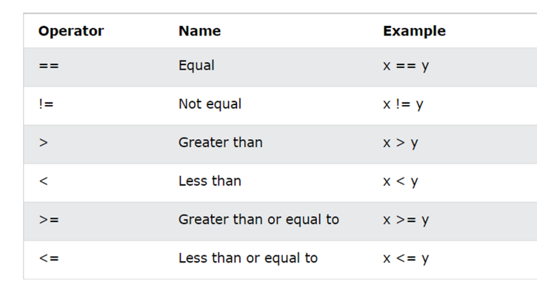

Functions | Lists
A function is a block of reusable code that is used to perform a specific task.  Instead of writing the same code repeatedly, you can create a function and ‘call’ the function.  Example:  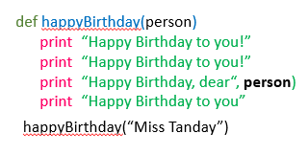 | A list in python contains items separated by commas within square brackets.  They are used to store multiple items in one variable.  For example:  Fruit = [“apple”, “banana”, “orange”, “strawberry”]  Each item in a list has an index position, which shows where it placed in the list.  Index positions always start with 0.  Index Positions 0 1 2 3 4  friends = [ “Tom”, “Sue”, “Danny”, “Joe”, “Mary” ]

