Key Words
Algorithm | Precise sequence of instructions
Computational thinking | Solving problems with or without a computer
Debugging | Looking at where a program might have errors or can be improved
Blocks | Scratch bricks that we can use to code algorithms
Decomposition | Breaking down a problem into smaller parts
Execute | A computer precisely runs through the instructions
Iteration | Doing the same thing more than once
Selection | Making choices
Sequence | Running instructions in order
Variable | Data being stored by the computer
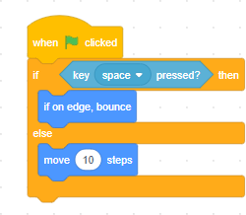
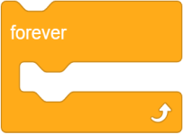
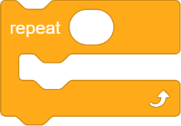
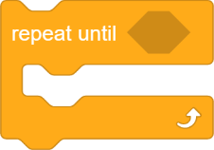
A computer inputs (this might be automatic or via human input), processes that input and then produces an output. as well as producing an output. For example when you use a keyboard and mouse, the mouse is used to input data into the computer to be processed and the output is visible on the computer monitor.
We use algorithms in everyday life. Example of an algorithm to get to school, to make a cup of tea, to make a pizza, to order a takeaway. These are just precise sequences of instructions.
Scratch is a block-based programming language. We can use predefined code drag and drop blocks to create a sequence of code.
Count controlled iteration will execute the commands a set number of times. Example: “perform 200 star jumps”

Condition-controlled iteration will execute the commands until the condition you set is no longer being met. Example: “perform
star jumps until 3pm”
A selection statement in programming allows a computer to evaluate an expression to ‘true’ or ‘false’ and then perform an action depending on the outcome.
Operators
Comparison operators allow us to compare using < > +
Logical operators use AND, OR, NOT
Sequence, selection and iteration are all processes. In order for computers to perform tasks there is more that is needed. For example a computer will take an input (this might be automatic or via human input) which the computer will then process and the output will be visible on the computer monitor.
Will loop the code forever.
Will repeat a set number of times.
Will repeat until a condition is met.
Variables are used to store data for use in a program. They can store lots of different types of data such as names and scores.

So set variable score to equal 0
If I score a goal then increase variable by 1.
A variable can only hold 1 piece of data at a time.

