Hillcrest School and Sixth Form
KEY INFORMATION
Simultaneous Equations:
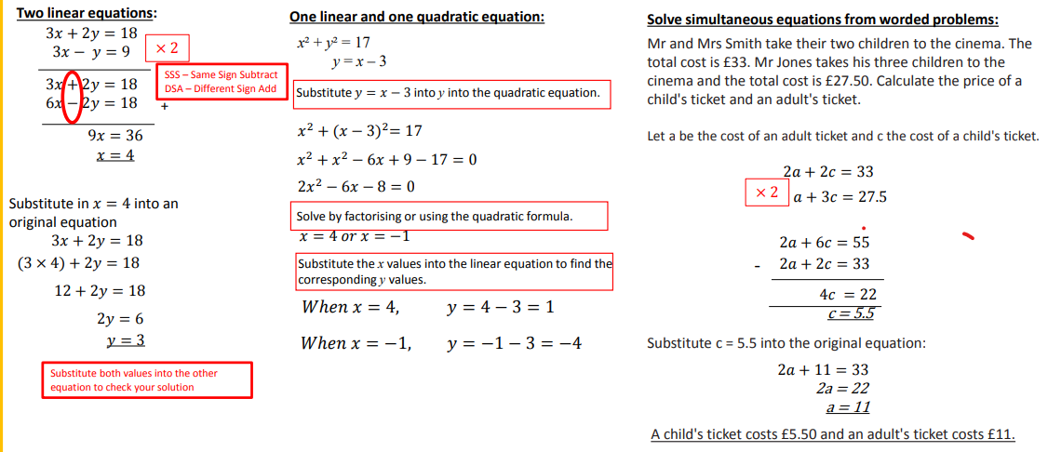
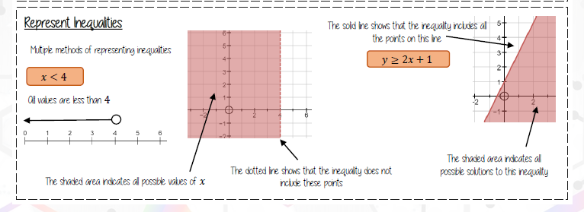

Department of Mathematics
KNOWLEDGE ORGANISER
YEAR 10 HIGHER TERM 3B –Equations and Inequalities
OUTCOMES
-Form and Solve linear equations
-Solve linear and quadratic simultaneous equations
-Solve problems using simultaneous equations.
-Solve a simple linear inequality and represent it on a number line.
-Show a graphical inequality
-Find regions that satisfy more than one graphical inequality.
-Show and solve quadratic inequalities graphically
-Recognise rational numbers, reciprocals, terminating decimals
and recurring decimals.
-Convert terminal decimals to fractions.
-Convert fractions to recurring decimals.
-Find reciprocals of numbers or fractions.

KEY WORDS
- Rational number – a number that can be written as an integer or fraction Examples: 5, ¾ , 3.2
- Terminating decimal – a decimal that has an end, 0.75 for example.
- Recurring decimal – a decimal that repeats indefinitely
- Simultaneous equations - equations involving two or more unknowns that are to have the same values in each equation.
- Reciprocal - one of a pair of numbers that, when multiplied together, equal 1. The reciprocal of 3 is ⅓
- Inequality - An inequality compares two values, showing if one is less than, greater than, or not equal to another value

